What am I?

#1. I fly around, I live in colonies, I produce wax and thick sugary material.

#2. I have scales, I am cold blooded, I breathe underwater, and I am a water dwelling animal.

#3. I am a mammal, I live in the eastern part of the U.S. I am active at night, and dwell in a tree.

#4. I am round and sweet. I have a reddish yellow rind. I grow in trees, and I start off with fragrant white flowers.

#5. I lived thousand of years ago, I fly. I am extinct. And I have a wing span as long as a bus.

#6. You wouldn’t think I am a mammal, but I am. I am also related to whales. I can help people. I have a beak like snout.

#7. I have short forelegs, I eat plants, and I spring off the ground . And I have a pocket on my stomach to hold my baby.

#8. I have long solid strings, and you put tomato sauce on me.

#9. I have a crunchy crust, and I am mostly served with pasta.

Super Challenge!!!
#10. My ingredients are: Tomatoes, spices, Chopped onions, Olives, Green peppers, and rice.

#1.bee
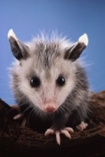
#2.fish
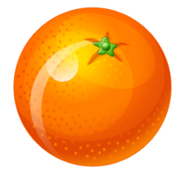
#3.opossum
#4.orange

#5.tranodon
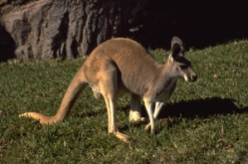
#6.dolphin
#7.kangaroo
#8.spaggetti
#9.garlic bread

#10.spanish rice

